Creating text

# Purpose

The following sections explains how to add/edit the type of content normally found in a Word document.

Each of the sections below explore a different content element, its style and how it is transformed online.

**Learn more about Word styles**

If you’re unfamiliar with using styles in Word documents, please refer to the plethora of online resources (e.g. [this one](https://shaunakelly.com/word/styles/tipsonstyles.html)). A quick search for *introduction word styles* should find most.

## Compare and constrast: Word and Blackboard

As you work through the examples in this section, it would be helpful to look at both the [Word document](https://griffitheduau-my.sharepoint.com/:w:/g/personal/d_jones6_griffith_edu_au/EZzeEf4bBQhLovFRBEmRGXYBFSPQs1rIt6aM9c_qsR-YBQ?e=5OYKbc) and [Blackboard versions](https://bblearn.griffith.edu.au/webapps/blackboard/content/listContent.jsp?content_id=_5578509_1&course_id=_82534_1&mode=quick&content_id=_5578509_1) of the document.

# Normal and the default text style

Any text that has a *Normal* style applied to it (this paragraph) or has a style that the content interface does not recognise, will be displayed as normal text.

Use of *italics*, **bold**, underline (doesn’t work), ~~strikethrough~~ and other character formatting will typically be represented in the online version, as shown in Figure 1

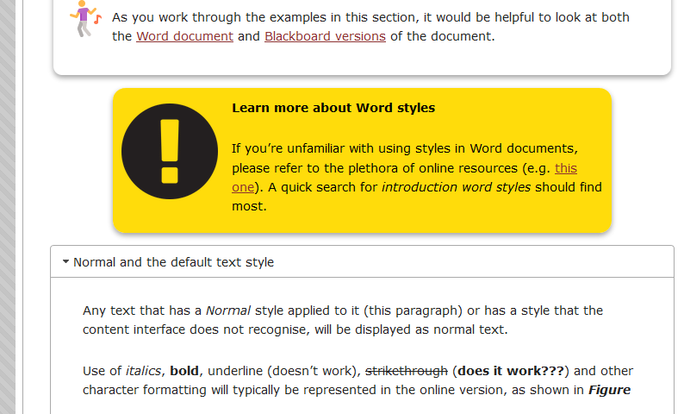

Figure 1 - Displaying normal text and some emphasis

# Headings and the accordion (Heading 1 style)

If you have viewed the Blackboard version of this document you will know that the content is transformed using [an accordion interface](https://en.wikipedia.org/wiki/Accordion_(GUI)). Figure 2 is an example of what this section looks like online. It shows that each heading becomes an accordion header. Clicking on such a header allows its content to be expanded (shown) or collapsed (hidden).

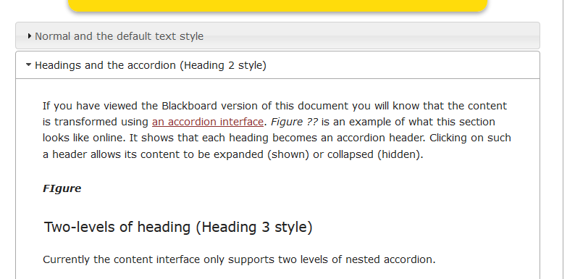

Figure 2 - Displaying headings, including accordions

## Two-levels of heading (Heading 2 style)

Currently the content interface only supports two levels of nested accordion.

Any text that has a *Heading 1* style applied to it becomes a top-level accordion. Any text with a *Heading 2* style applied will become a second-level accordion. Any text with lower heading styles (e.g. *Heading 3*) will just be displayed as a heading.

# Tables

Any Word table will be default be converted into a HTML table. Currently each HTML/online table is formatted using a single style (Figure 3).

|  |  |
| --- | --- |
| **Heading 1** | **Heading 2** |
| Hello | There |
| This | Is |
| A | Table |

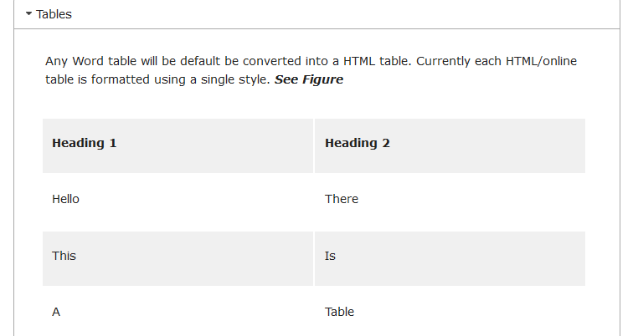

Figure 3 - Displaying tables

# Quotes

There is also support for quotes, references and bibliographies. In the following example (and on the next page), I’ve used my citation management software ([Zotero](https://www.zotero.org/)) to insert citations and the bibliography. This should work with other citation management software.

Any text with the style *Quote* or *Quotations* will be converted into a style HTML quote. If you compare the Word document version with the online version (see Figure 4), you will see that the quote styles are very different between media.

Solomon and Black (2008) argue that

In order to ‘try out’ new ways of thinking, we need to perceive ourselves as having some agency in or control over what we are doing. As long ago as 1976, Barnes identified a ‘performance climate’ in many classrooms (1976: 111) which detractce from such agency, creating a dynamic which disempowers pupils and prevents them from reflecting on their own thinking and pre-existing knowledge in order to relate new to old. The loss of collaboration with teachers in negotiating learning causes pupils to lok only for the answer that a teacher wants: ‘When a teacher assess what his pupils say he distances himself from their views, and allies himself with external standards which may implicitly devalue what the learner himself has constructed’ (1976: 111). In contrast, ‘when a teacher replies to his pupils, he is by implication taking their view of the subject seriously, even though he may wish to extend and modify it` (1976: 111): such interactions attribute a higher stats to the learners’ contributions, underlining their ownership of the learning that is going on. It is the dialogic quality of such interactions – questioning to invite surmise and the reorganisation of ideas, and (most importantly) collaborative discussion which picksup what is said and extends, modifies or even challenges it – that enables genuine construction of knowledge.

Johanson and Hasselbring (2018) – on another topic entirely – make the following argument

Because of this ideal of generality, the question of how specifically computational scientists should develop their software in a well-engineered way, would probably have perplexed a software engineer and the answer might have been: “Well, just like any other application software.

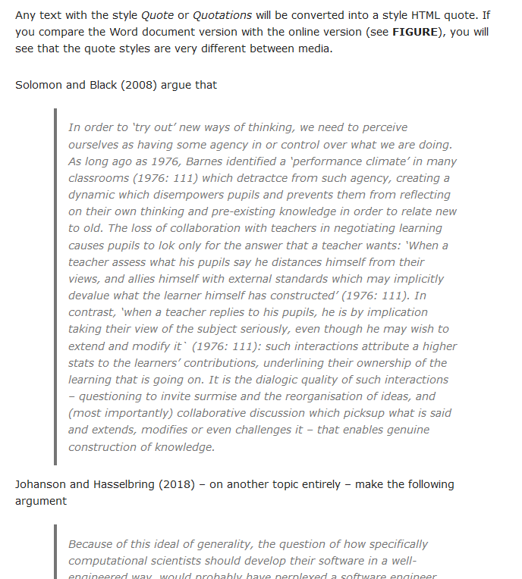

Figure 4 - Displaying quotes

# Bibliography/Reference lists

The following bibliography was created by [Zotero](https://www.zotero.org/) and inserted into this document. In just the same way as if you were using Endnote, Mendeley or some other form of citation management software (including manual copy and pasting). Figure 5 shows what it looks like in Blackboard.

Johanson, A., & Hasselbring, W. (2018). Software Engineering for Computational Science: Past, Present, Future. *Computing in Science & Engineering*. https://doi.org/10.1109/MCSE.2018.108162940

Solomon, Y., & Black, L. (2008). Talking to learn and learning to talk in the mathematics classroom. In *Exploring talk in school: inspired by the work of Douglas Barnes*. SAGE. Retrieved from https://e-space.mmu.ac.uk/90666/

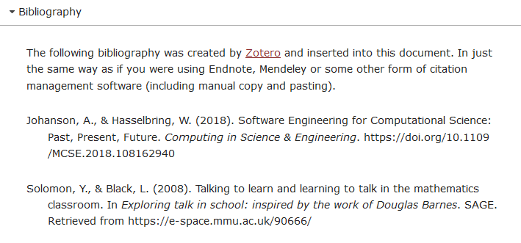

Figure 5 - Displaying a bibliograph (APA referencing)

# Footnotes

Microsoft Word enables [the creation of footnotes](https://support.microsoft.com/en-us/office/insert-footnotes-and-endnotes-61f3fb1a-4717-414c-9a8f-015a5f3ff4cb) [1]. The Content Interface now supports footnotes (endnotes not yet). But with some differences.

In Word, a footnote creates a reference with the detail at the bottom of the page. As shown in the following screenshot.

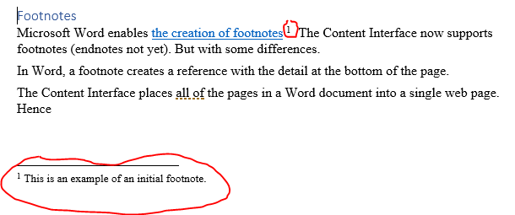

Figure 6 - Footnotes in Word

The Content Interface places all of the pages in a Word document into a single web page. Changing the notion of “bottom of the page”. Due to this difference the Content Interface handles footnotes in two ways.

First, the content of footnotes appear as tooltips. i.e. if you roll your mouse over a footnote reference a small window pops up with the content of the footnote as shown in the following image.

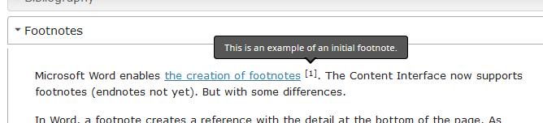

At the end of the document a new **Footnotes** section is added that contains a list of all footnotes throughout the Word document. e.g. the following image.

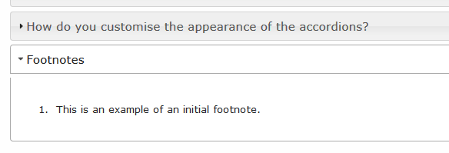

1. This is an example of an initial footnote.